How to set up Alma so that the “Originating System” in Analytics will be properly populated | 
Yoel Kortick
Senior Librarian

Introduction
This document will assist those institutions which may have text “Unknown” appear in the Alma Analytics field “Originating System” from the “Bibliographic details” folder for records imported via “Search Resources”. The text “Unknown” may appear even though in Alma there is a real originating system. For example, below for MMS ID 9912712952402411
- Alma states that the Originating System is “WorldCat (OCLC)”
- Analytics states that the Originating System is “Unknown”

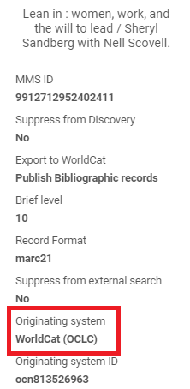

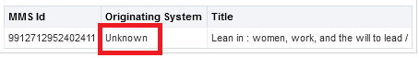

Here is how to properly configure the system to not have "Unknown" in the "Originating System" in Alma Analytics

In the table "Originating Systems for MD Records" at "Configuration Menu > Resources > Record Import" the "code" must appear exactly as the resource appears in "External Search Resources" at "Configuration Menu > Resources > Search Configuration > External Search Resources".

Thus, if the resource name is "WorldCat (OCLC)" then the code must also be " WorldCat (OCLC)".

Here is a side-by-side comparison of what appears in "External Search Resources", and what should and should not appear in "Originating Systems for MD Records".

External Search Resources | "Originating Systems for MD Records"
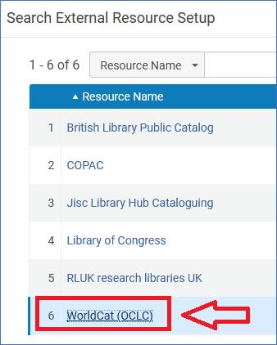 | Instead of this:  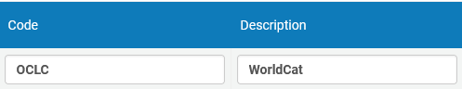  It should be this:  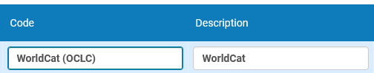

After making the above change we can test the system.
As an example, we will import a record from resource "WorldCat (OCLC)". MMSID 9912727275002411 has been imported and in Alma the originating system appears:
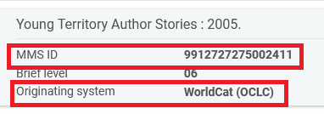
Now (after the next nightly ETL update in Analytics) we can check the originating system in Alma Analytics. We see that it is correctly not “Unknown” and it is instead “WorldCat”. This is the text coming from the “Description” column of the table "Originating Systems for MD Records" mentioned above, where the code is “WorldCat (OCLC)” .
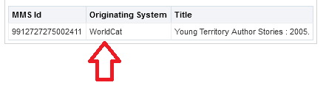

Here is the relevant section of the table "Originating Systems for MD Records":

